**[RAILWAY ENQUIRY SYSTEM]**

## A PROJECT REPORT

***Submitted by***

# [RUDRA RANA]

## [225690694073]

***In partial fulfillment for the award of the degree of***

# MASTER OF COMPUTER APPLICATIONS

***in* [Government MCA College,Maninagar]**



# Gujarat Technological University, Ahmedabad

**[June, 2023]**

 

# [Government MCA College,]

**Shree K.K Shastri Campus,Near Khokhra Circle**

**CERTIFICATE**

This is to certify that the project report submitted along with the project entitled **Railway Enquiry System** has been carried out by **Rudra Rana(225690694073)** under my guidance in partial fulfillment for the degree of Master of Computer Application in 2nd Semester of Gujarat Technological University, Ahmadabad during the academic year 2022-23.

|  |  |  |
| --- | --- | --- |
| **Prof Jaimin Dave** | **Prof Bhavesh B Prajapati** | **Dr Chetan B.Bhatt** |
| Assitant Professor(IT), | HOD, | Principal |
| Government MCA College, | Government MCA College, | Government MCA College, |
| Maninagar,Ahmedabad | Maninagar,Ahmedabad | Maninagar,Ahmedabad |

# ACKNOWLEDGEMENT

We are grateful to thank to all the faculties of “Government MCA College”. They always encouraged and inspired us. They always provided us right guidance.

We sincerely acknowledge that without their support this project would not have been feasible. Our thanks and appreciations also to our friends who helped us in our project.

Prepared by:

**Dhruv Chauhan [225690694007]**

**Shubham Mishra [225690694058]**

**Rudra Rana [225690694073]**

# ABSTRACT

The Railway Enquiry System is an web application that allows to search the train, book the tickets, cancellation of the tickets, payment method and user will be able to ask the queries to the admin section, Admin will solve the issue and send the answer from admin side. This answer will automatically forward via mail to the user and also will be available to the user login. This system solves the issue of the waiting for user queries and can be solved by admin via user ticket context.

Frontend development is done using the Html and Css with the help of javascript. Backend development is done using the Python.Framework we are using is Django. Sqlite is the database is we are using in this project.

# LIST OF FIGURES

1. **Use Case Diagram 14**
   1. **User side Diagram 14**
   2. **Admin side Diagram 15**
2. **Class Diagram 16**
3. **Activity Diagram 17**

# LIST OF TABLES

* + 1. **Passenger Master 18**
    2. **Ticket Master 18**
    3. **Train Master 18**
    4. **Train Schedule Master 19**
    5. **Bill 19**

**TABLE OF CONTENTS**

Page Numbers

**Acknowledgement I**

**Abstract II**

**List of Figures III**

**List of Tables IV**

**Table of Contents V**

1. **Introduction**
   1. **Existing System 3**
   2. **Need for the New System 4**
   3. **Objective of the New System 5**
   4. **Problem Definition 5**
   5. **Project Profile 6**
   6. **Assumptions and Constraints 7**
   7. **Advantages and Limitations of the Proposed System 7**

## Requirement Determination & Analysis

* 1. **Requirement Determination 8**
  2. **Features 8**
  3. **Technologies used 9**
  4. **Targeted Users 12**

V

1. **System Design**
   1. Use Case Diagram 14
   2. Class Diagram 16
   3. Activity Diagram 17
   4. Data Dictionary 18
2. Development
   1. Screen Shots 20
3. Proposed Enhancements 45
4. Conclusion 46
5. Bibliography 47

# ABOUT INDIAN RAILWAY

Indian Railways (IR) is a statutory body under the ownership of the Ministry of Railways, Government of India that operates India's national railway system.[8] It manages the fourth largest national railway system in the world by size, with a total route length of 68,043 km (42,280 mi), running track length of 102,831 km (63,896 mi) and track length of 128,305 km (79,725 mi) as of 31 March 2022.[9][5] 58,812 km (36,544 mi) of all the gauge routes are electrified with 25 kV 50 Hz AC electric traction as of 1 April 2023.[6]

In 2020, Indian Railways carried 808.6 crore (8.086 billion) passengers and in 2022, Railways transported 1418.1 million tonnes of freight.[10][5] It runs 13,169 passenger trains daily, on both long-distance and suburban routes, covering 7,325 stations across India.[5] Mail or Express trains, the most common types of trains, run at an average speed of 50.6 km/h (31.4 mph). Suburban EMUs run at an average speed of 37.5 km/h (23.3 mph). Ordinary passenger trains (incl. mixed) run at an average speed of 33.5 km/h (20.8 mph).[5] The maximum speed of passenger trains varies, with the Vande Bharat Express running at a peak speed of 180 km/h (110 mph).

In the freight segment, IR runs 8,479 trains daily.[5] The average speed of freight trains is around 42.2 km/h (26.2 mph). The maximum speed of freight trains varies from 60– 75 km/h (37–47 mph) depending on their axle load with 'container special' trains running at a peak speed of 100 km/h (62 mph).

As of March 2020, Indian Railways' rolling stock consisted of 2,93,077 freight wagons, 76,608 passenger coaches and 12,729 locomotives.[5] IR owns locomotive and coach- production facilities at several locations in India. It had 1.38 Million employees as of March 2020, making it the world's tenth-largest employer.[5] The government has committed to electrifying India's entire rail network by 2023–24, and become a "net zero (carbon emissions) railway" by 2030.[11]

# 1. INTRODUCTION

There are many different types of information on our website that can be used to book train tickets. Users will be able to look for train availability, exact fares, arrival and departure times, as well as book tickets using debit, credit, or master cards. If users need to cancel their tickets after booking them, they may do so with ease as well. The major goal of keeping a database for the Railway Reservation System is to minimise human errors that might occur when purchasing and cancelling tickets and to make it easier for both customers and service providers to keep records of their clients and the seats that are accessible to them. Many of the gaps that exist in manual record maintenance can be closed by automation. Data gathering and processing will happen quickly. The proposed system can be web enabled for future development so that customers can inquire in various ways regarding trains between stations. Due to this, they occasionally run into a lot of issues and have numerous consumer conflicts. To address the aforementioned issue, we created a database that contains consumer information.

## EXISTING SYSTEM

There are many railway inquiry system is available in the market but in that inquiry response time is very slow like we called to the customer care number and then tell them to our query and they provide the solution.It takes lot of time.There is also one system that is manual ticket booking system.In this manual ticket booking system we have to go to the railway station .It consumes lot of time and money.After going there we have to fill the reservation form and give it to the railway officer.After we have to pay the amount of the ticket which is very frustrating so we have to try and build the online railway booking system.

## PROPOSED SYSTEM

Users can purchase tickets for any train that has open seats. For this, the user must enter the desired train's number and the desired departure date. The validity of the train number is checked before to reserving a ticket for the user. After verifying the train number and time, it is then determined if a seat is available. If so, the ticket is reserved with a confirmed status, and a matching ticket ID is generated and kept with the user's other information. Once purchased, a ticket may be cancelled at any time. The passenger must present the ticket ID (the special Key) in order to do this.The user has a variety of payment options (UPI, Cash, Card).It is easy to search for the wished train as train code, train number are there, you do not need to remember those,you just have to mention source and destination.A fare table is already ther so that passenegers can know the specific price of their ticket.and as it is stored there the amount cannot wrong.Due to excessive amount of work the employers tend to do mistakes by manual form.Here the chance of mistake is minimum reservation can be done easily.The overall method is very easy and based on few steps.No Huge amount of knowledge is needed to complete the task.

## OBJECTIVE OF THE NEW SYSTEM

The main Objective of proposed system is used to provide online booking solution to customer .It will automate some of the basic operation of an online ticket. Scope would be to provide basic functionalities using a web application so that those manual process can be automated .It will include to provide administration access to vendors and admins and user specific access to customer.

## PROBLEM DEFINITION:

The main problem definition is that ticket booking websites are available but some of they are to complex and some of they are not user friendly and some of they are provided too much functionalities which is not needed.

# PROJECT PROFILE:

* Project Name: Railway Inquiry System
* Type of Application: Web Application
* Project Description: In this project we have try to give the best options for the user to search the train,book the ticket, search the PNR inquiry,cancellation of the ticket and ask the question.
* Team Size:3
* Front End:HTML&CSS and Bootstrap
* Backend:Python
* Database tools:SQLite
* Framework:Django
* Tools used:PyCharm,Visual Studio Code

## ASSUMPTIONS AND CONSTRAINTS:

* ASSUMPTIONS:
  + 1. When we think to build this we think that it is very easy project that we have take.
    2. It is only one month work to try and complete the project.
* CONSTRAINTS:

1. Firstly we don’t know the Django and python in deeply
2. So we try to learn the Django framework and python
3. This is very new project and new technology for us so we are very frustrated how can we make them
4. How to connect the database
5. How to Make The User Friendly Web Interface

## ADVANTAGES AND LIMITATIONS OF THE PROPOSED SYSTEM:

* **ADVANTAGES:**
  + 1. Our Website is having the best user interface
    2. Our Website is having the enough features to search any information regarding the railways
    3. We are trying to reduce the response time against the any user query.
* **DISADVANTAGES:**

1. As we are in learning phase we are provided limited stations
2. Our website is having the limited number of stations so we can’t search any train or information beyond them.

# REQUIREMENT DETERMINATION & ANALYSIS

## REQUIREMENT DETERMINATION

Online railway ticket reservation refers to a website where customers may purchase tickets and check train availability. This website was made primarily to satisfy the following criteria, and it has the following features:-

* + 1. A centralised database that will house all of the data.
    2. An online resource that offers real-time details on the costs and availability of tickets.
    3. Every registered user has access to their booking id for any reservations made in their name.
    4. Every logged-in user has the option to change their password whenever they choose.
    5. Every guest user has access to train availability, ticket prices, arrival and departure times, and other information.
    6. Every logged-in user has the option to print his ticket whenever he wants.

## 2.2. FEATURES

* + - BOOK TICKETS
    - QUERIES
    - TRAIN AND SCHEDULE
    - PROFILE UPDATE
    - BOOK TICKETS
    - CANCELLATION TICKETS
    - ASK THE QUERY

## TECHNOLOGIES USED

* + - PYTHON

Python was the language of choice for this project. This was an easy decision for the multiple reasons. Python as a language has an enormous community behind it. Any problems that might be encountered can be easily solved with a trip to Stack Overflow. Python is among the most popular languages on the site which makes it very likely there will be a direct answer to any query.

* + - HTML

HTML stands for Hyper Text Markup Language.HTML is the standard markup language for creating Web pages.HTML describes the structure of a Web page.HTML consists of a series of elements.HTML elements tell the browser how to display the content.HTML elements label pieces of content such as "this is a heading", "this is a paragraph", "this is a link", etc.

* + - JAVASCRIPT

JavaScript is the world's most popular programming language. JavaScript is the programming language of the Web.

JavaScript is easy to learn.

This tutorial will teach you JavaScript from basic to advanced.

* + - SQLITE

SQLite is an in-process library that implements a [self-](https://www.sqlite.org/selfcontained.html) [contained,](https://www.sqlite.org/selfcontained.html) [serverless,](https://www.sqlite.org/serverless.html) [zero-configuration,](https://www.sqlite.org/zeroconf.html) [transactional](https://www.sqlite.org/transactional.html) SQL database engine. The code for SQLite is in the [public domain](https://www.sqlite.org/copyright.html) and is thus free for use for any purpose, commercial or private. SQLite is the [most widely](https://www.sqlite.org/mostdeployed.html) [deployed](https://www.sqlite.org/mostdeployed.html) database in the world with more applications than we can count, including several [high-profile projects.](https://www.sqlite.org/famous.html)

SQLite is an embedded SQL database engine. Unlike most other SQL databases, SQLite does not have a separate server process. SQLite reads and writes directly to ordinary disk files. A complete SQL database with multiple tables, indices, triggers, and views, is contained in a single disk file. The database [file format](https://www.sqlite.org/fileformat2.html) is cross-platform - you can freely copy a database between 32-bit and 64-bit systems or between [big-](http://en.wikipedia.org/wiki/Endianness) [endian](http://en.wikipedia.org/wiki/Endianness) and [little-endian](http://en.wikipedia.org/wiki/Endianness) architectures. These features make SQLite a popular choice as an [Application File Format](https://www.sqlite.org/appfileformat.html). SQLite database files are a [recommended storage format](https://www.sqlite.org/locrsf.html) by the US Library of Congress. Think of SQLite not as a replacement for [Oracle](http://www.oracle.com/database/index.html) but as a replacement for [fopen()](http://man.he.net/man3/fopen)

SQLite is a compact library. With all features enabled, the [library](https://www.sqlite.org/footprint.html) [size](https://www.sqlite.org/footprint.html) can be less than 750KiB, depending on the target platform and compiler optimization settings. (64-bit code is larger. And some compiler optimizations such as aggressive function inlining and loop unrolling can cause the object code to be much larger.) There is a tradeoff between memory usage and speed. SQLite generally runs faster the more memory you give it.

* + - DJANGO FRAMEWORK

Django is a high-level Python web framework that enables rapid development of secure and maintainable websites. Built by experienced developers, Django takes care of much of the hassle of web development, so you can focus on writing your app without needing to reinvent the wheel. It is free and open source, has a thriving and active community, great documentation, and many options for free and paid-for support.

Django helps you write software that is:

Complete

Django follows the "Batteries included" philosophy and provides almost everything developers might want to do "out of the box". Because everything you need is part of the one "product", it all works seamlessly together, follows consistent design principles, and has extensive and [up-to-date documentation](https://docs.djangoproject.com/en/stable/).

Versatile

Django can be (and has been) used to build almost any type of website

— from content management systems and wikis, through to social networks and news sites. It can work with any client-side framework, and can deliver content in almost any format (including HTML, RSS feeds, JSON, and XML).

Internally, while it provides choices for almost any functionality you might want (e.g. several popular databases, templating engines, etc.), it can also be extended to use other components if needed.

* + - BOOTSTRAP

Bootstrap is a free front-end framework for faster and easier web development

Bootstrap includes HTML and CSS based design templates for typography, forms, buttons, tables, navigation, modals, image carousels and many other, as well as optional JavaScript plugins

Bootstrap also gives you the ability to easily create responsive designs

## TARGETED USERS

Basically we are in the learning phase so initially we targeted our college classmate to use this website and after successfully using this website we targeted the users who want the information and travelling into the railways.

# SYSTEM DESIGN

1. System Design is the process of designing the architecture, components, and interfaces for a system so that it meets the end-user requirements. Understand the requirements: Before starting the design process, it is important to understand the requirements and constraints of the system. This includes gathering information about the problem space, performance requirements, scalability needs, and security concerns.
2. Identify the major components: Identify the major components of the system and how they interact with each other. This includes determining the relationships between different components and how they contribute to the overall functionality of the system.
3. Choose appropriate technology: Based on the requirements and components, choose the appropriate technology to implement the system. This may involve choosing hardware and software platforms, databases, programming languages, and tools.
4. Define the interface: Define the interface between different components of the system, including APIs, protocols, and data formats.
5. Design the data model: Design the data model for the system, including the schema for the database, the structure of data files, and the data flow between components.
6. Consider scalability and performance: Consider scalability and performance implications of the design, including factors such as load balancing, caching, and database optimization.
7. Test and validate the design: Validate the design by testing the system with realistic data and use cases, and make changes as needed to address any issues that arise.
8. Deploy and maintain the system: Finally, deploy the system and maintain it over time, including fixing bugs, updating components, and adding new features as needed.

## USE CASE DIAGRAM

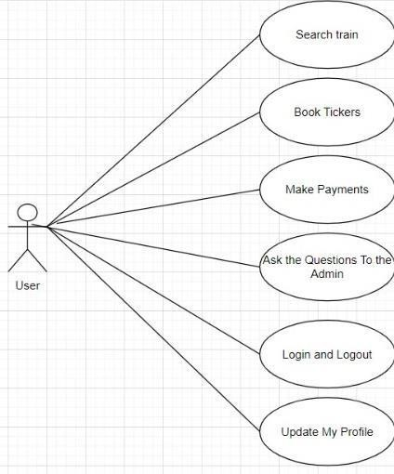

* + **USER SIDE USE CASE DIAGRAM**

## ADMIN SIDE USE CASE DIAGRAM

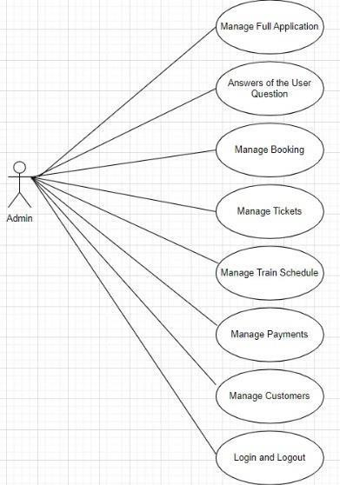

## CLASS DIAGRAM

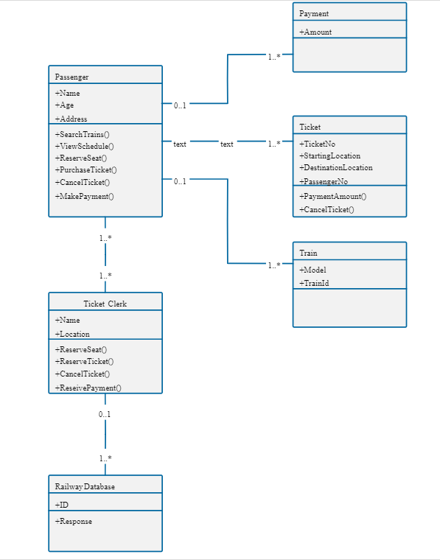

## ACTIVITY DIAGRAM

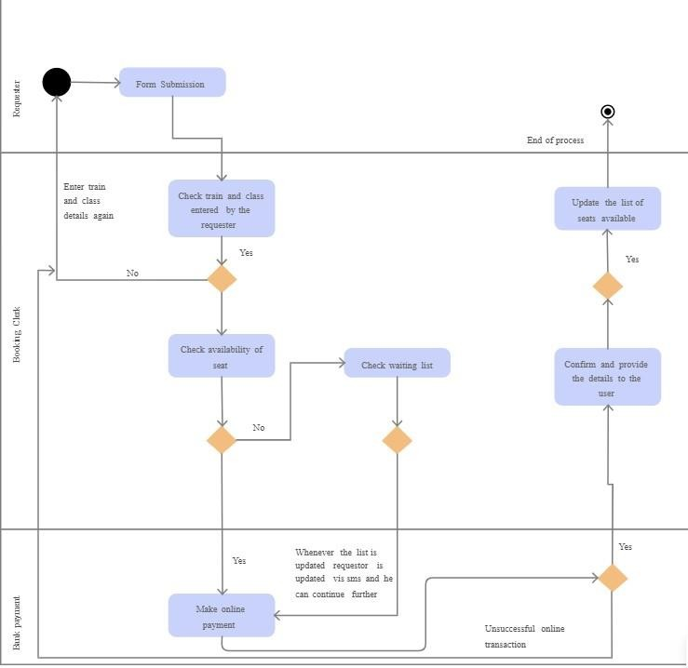

## DATA DICTIONARY

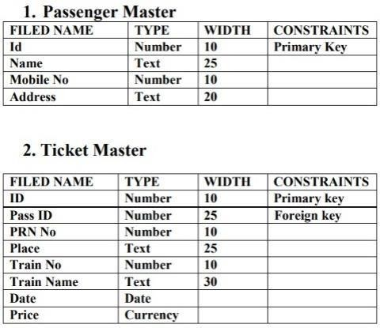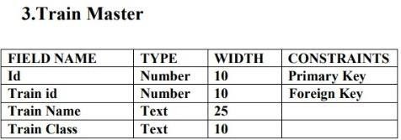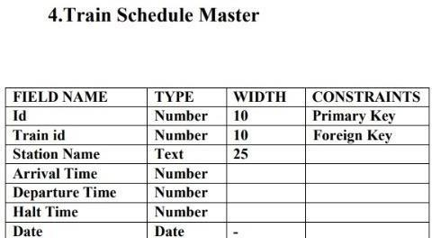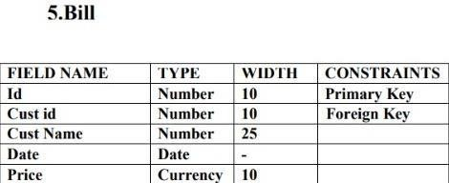

# DEVELOPMENT

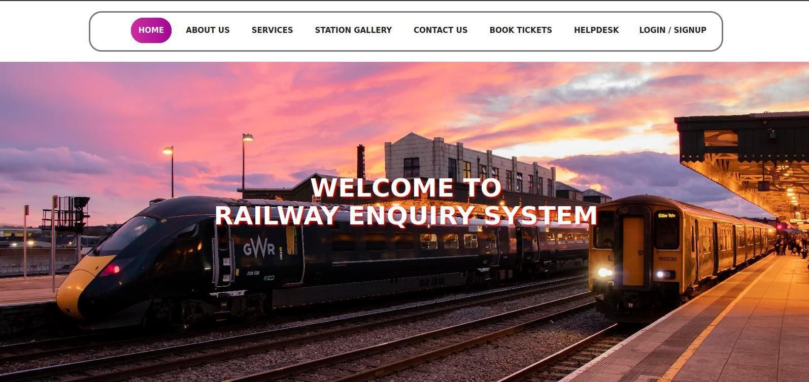

## SCREENSHOTS

**HOMEPAGE**

## OUR SERVICES PAGE

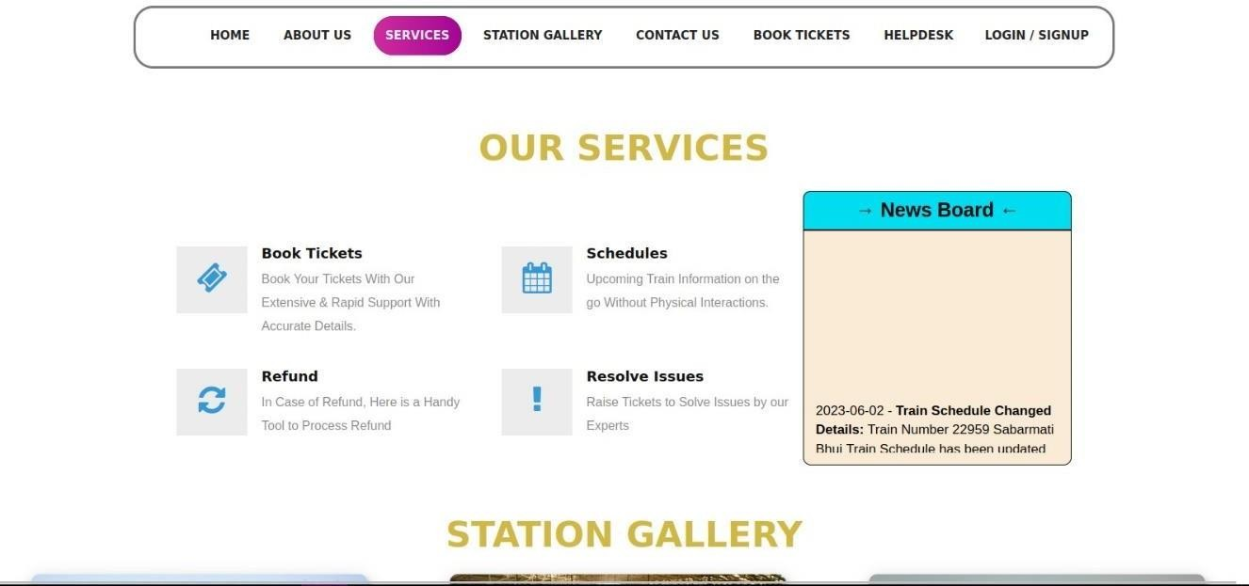

**STATION GALLERY PAGE**

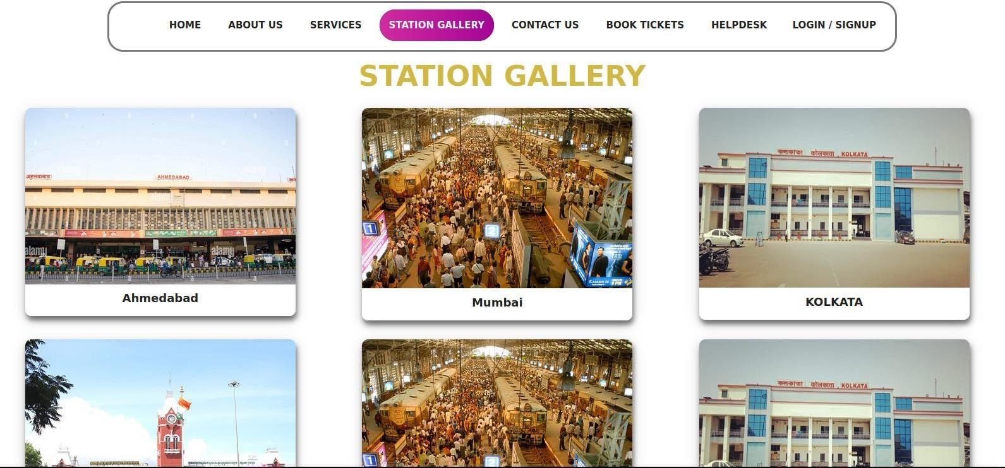

––

## CONTACT US PAGE

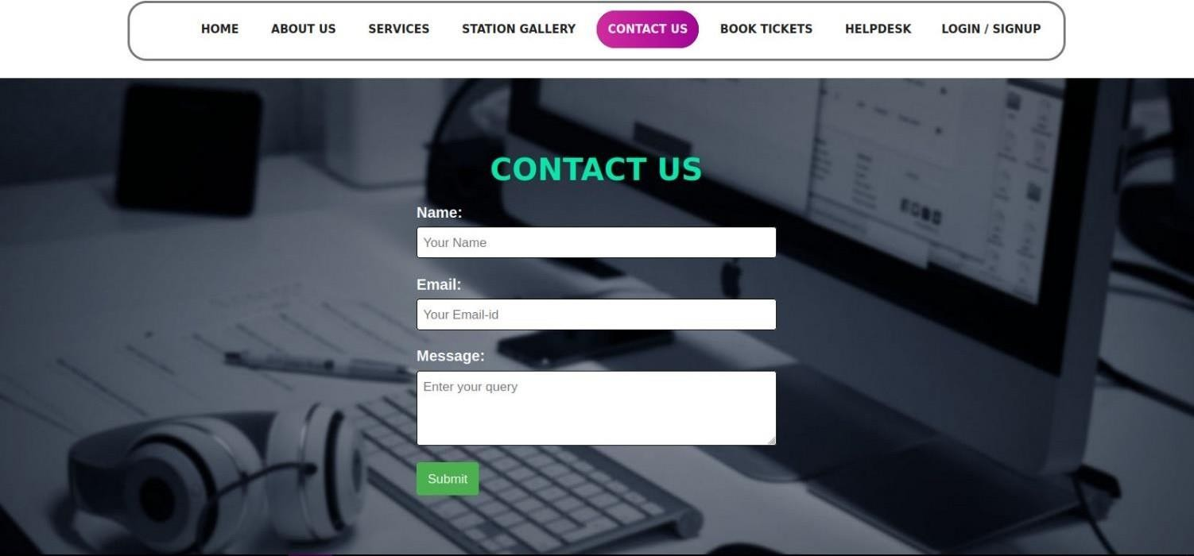

**SIGNUP FORM**

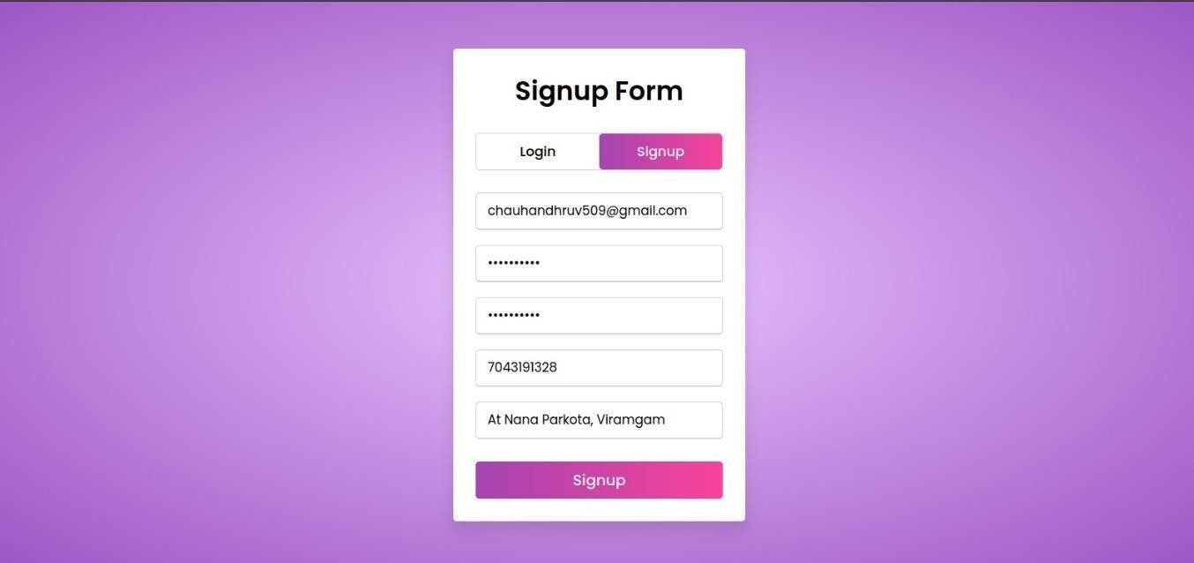

## LOGIN FORM

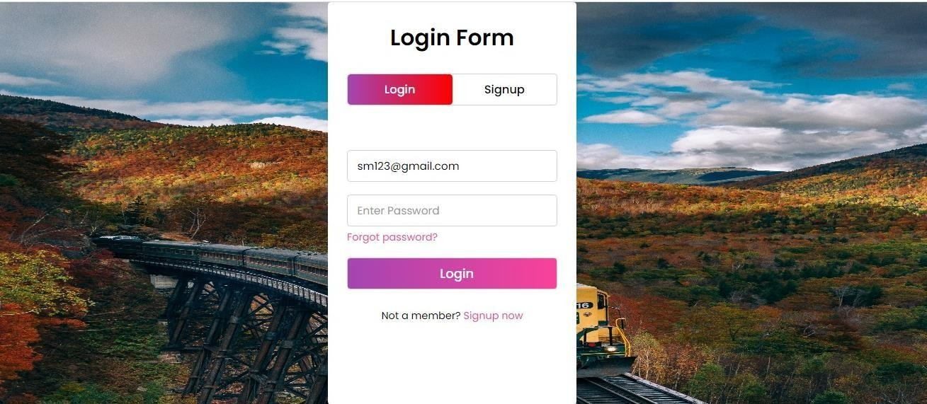

**USER DASHBOARD**

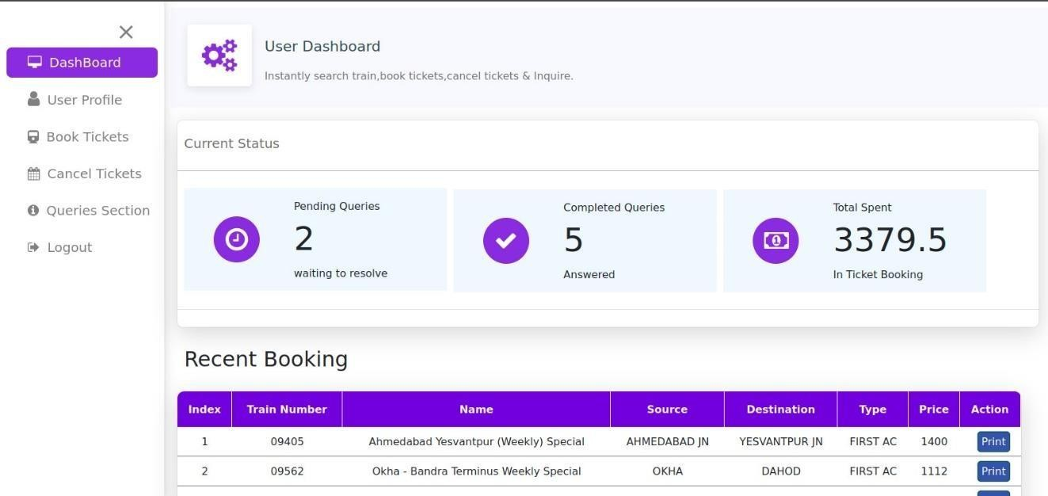

## PROFILE SECTION

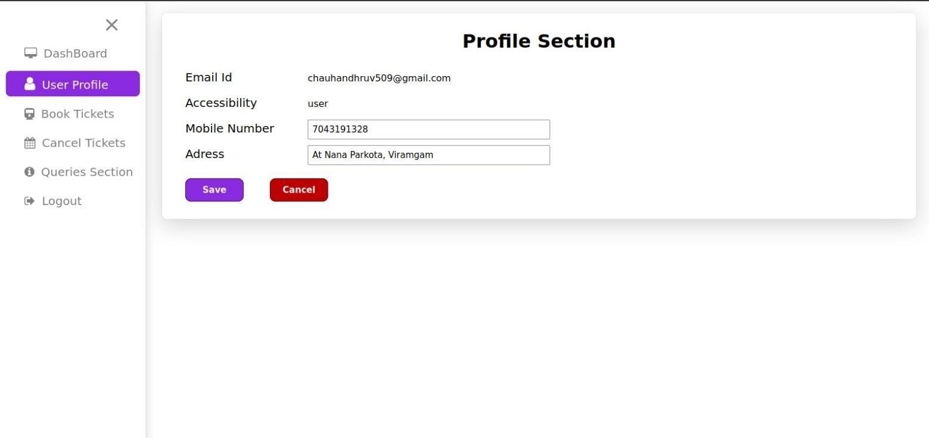

**BOOK TICKETS**

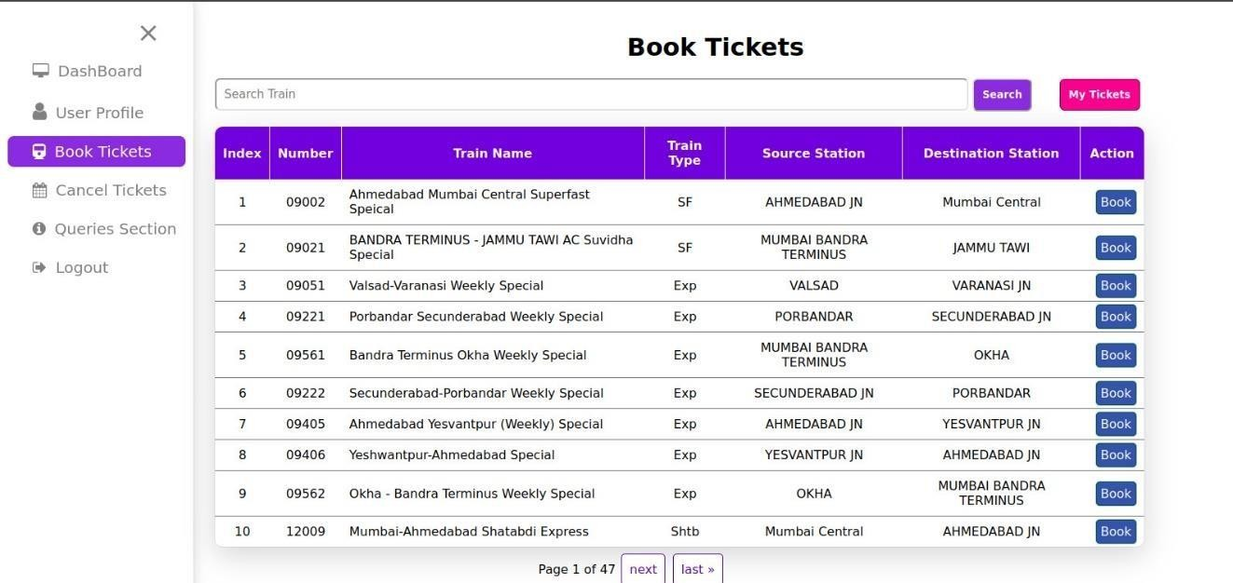

## TICKET DETAILS

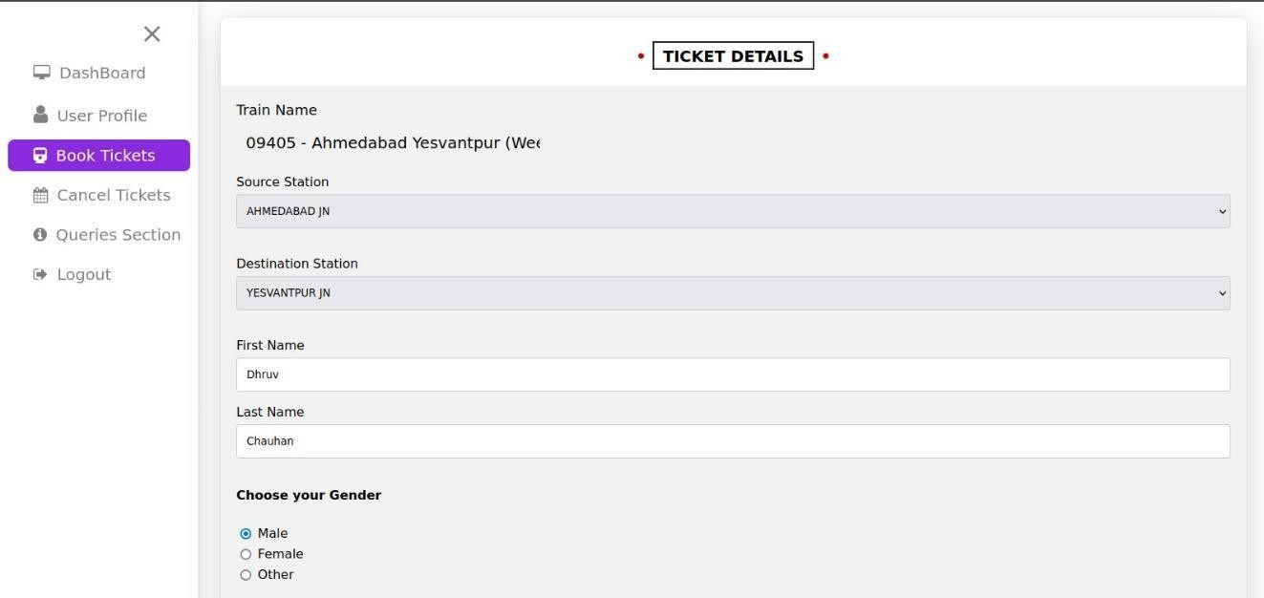

**CARD PAYMENT OPTION**

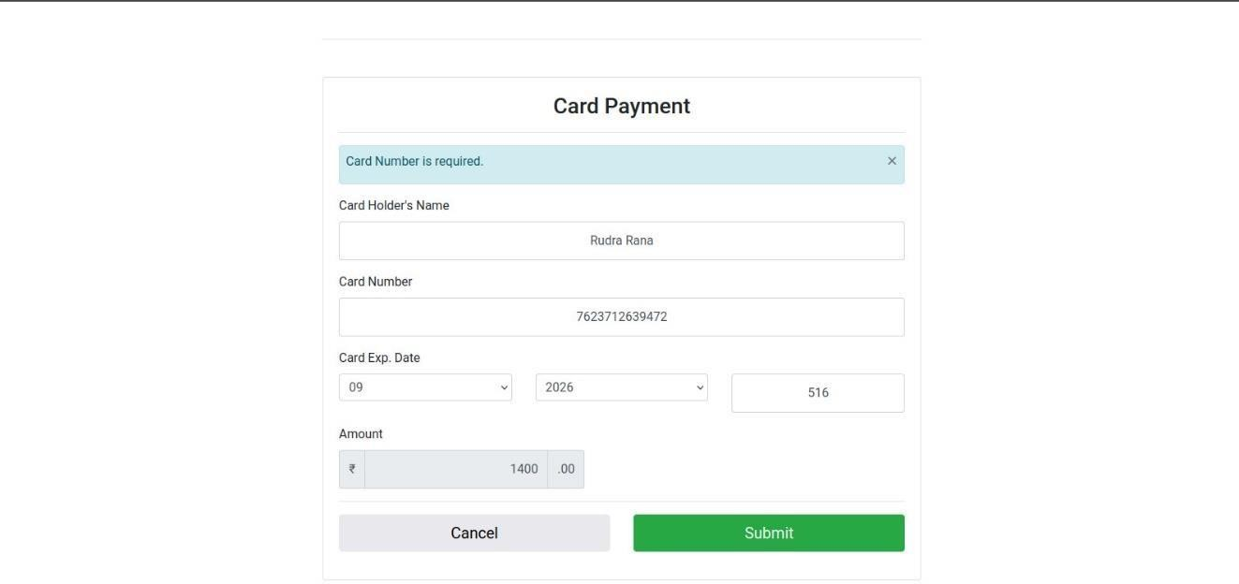

## SUCCESSFUL BOOKING TICKET

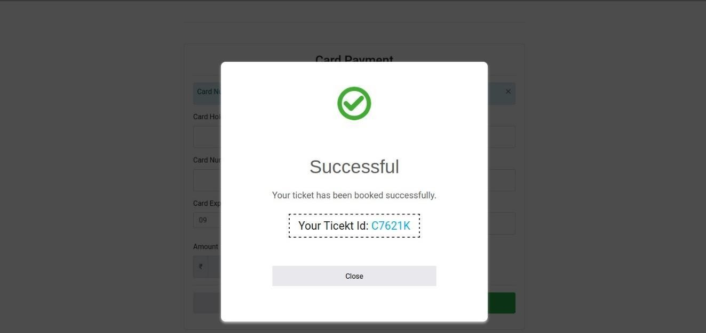

**BOOKING HISTORY**

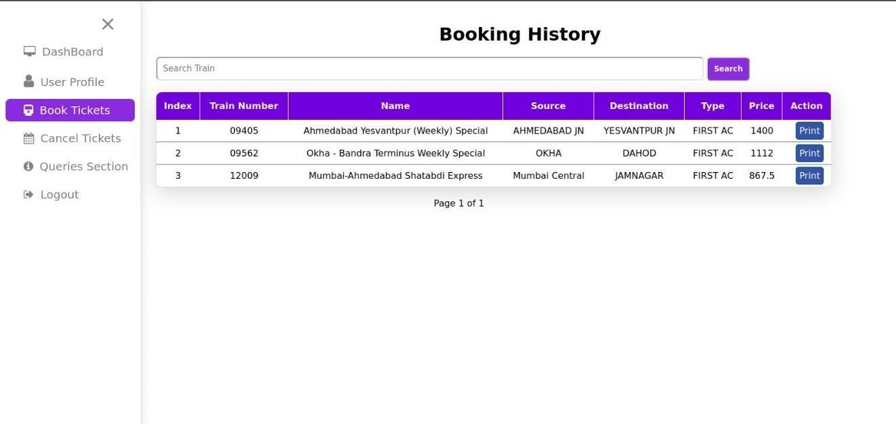

## CANCEL TICKETS

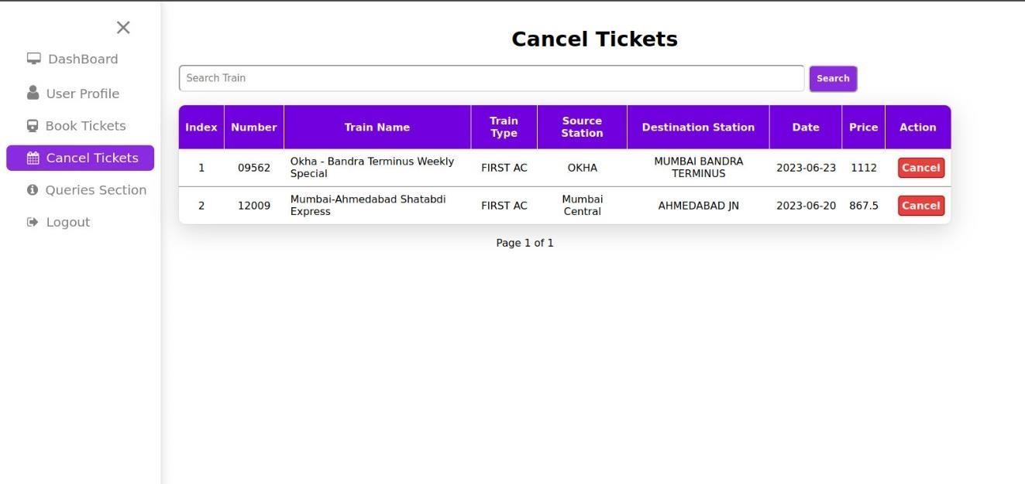

**ASK THE QUERIES**

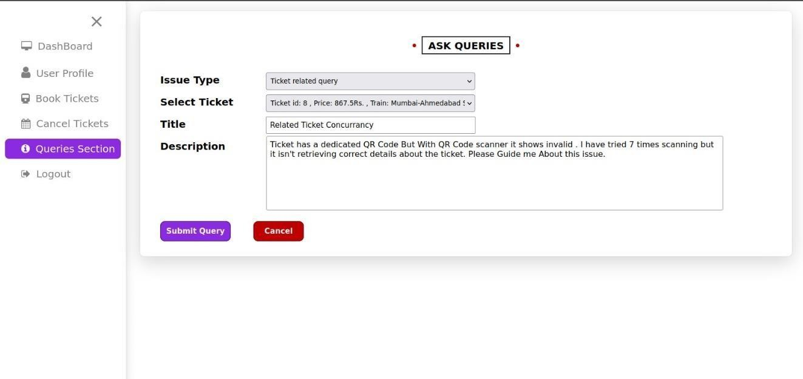

## MANAGE QUERIES

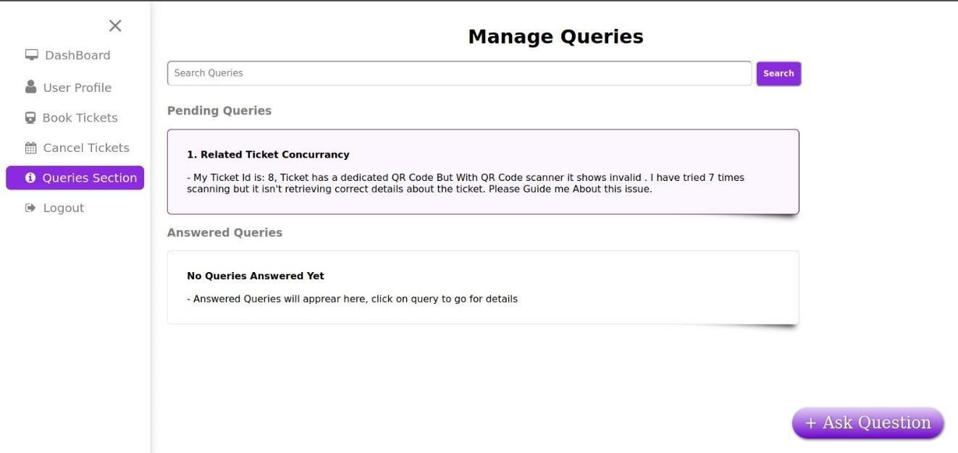

**VIEW QUERY**

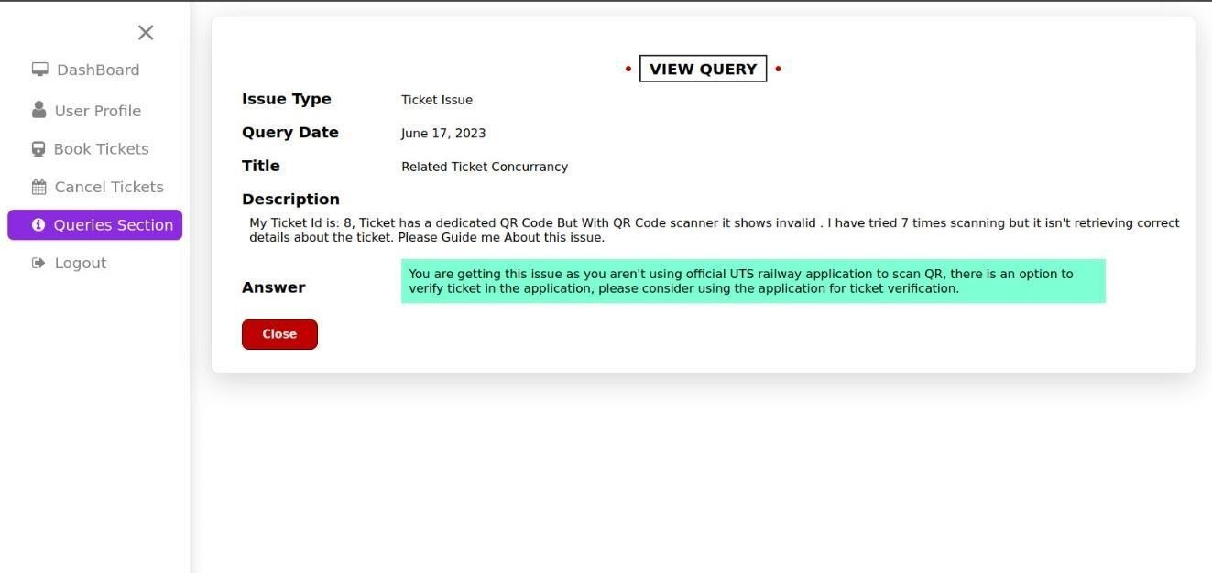

# ADMIN SIDE SCREENSHOTS

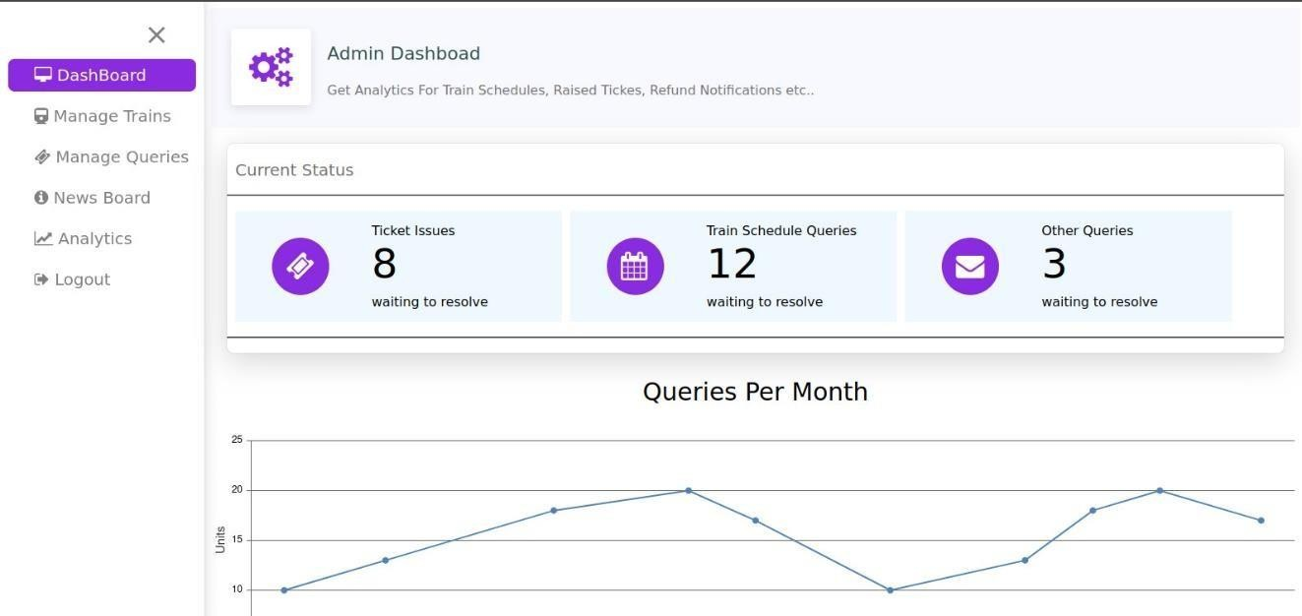

## ADMIN DASHBOARD

**MANAGE TRAINS**

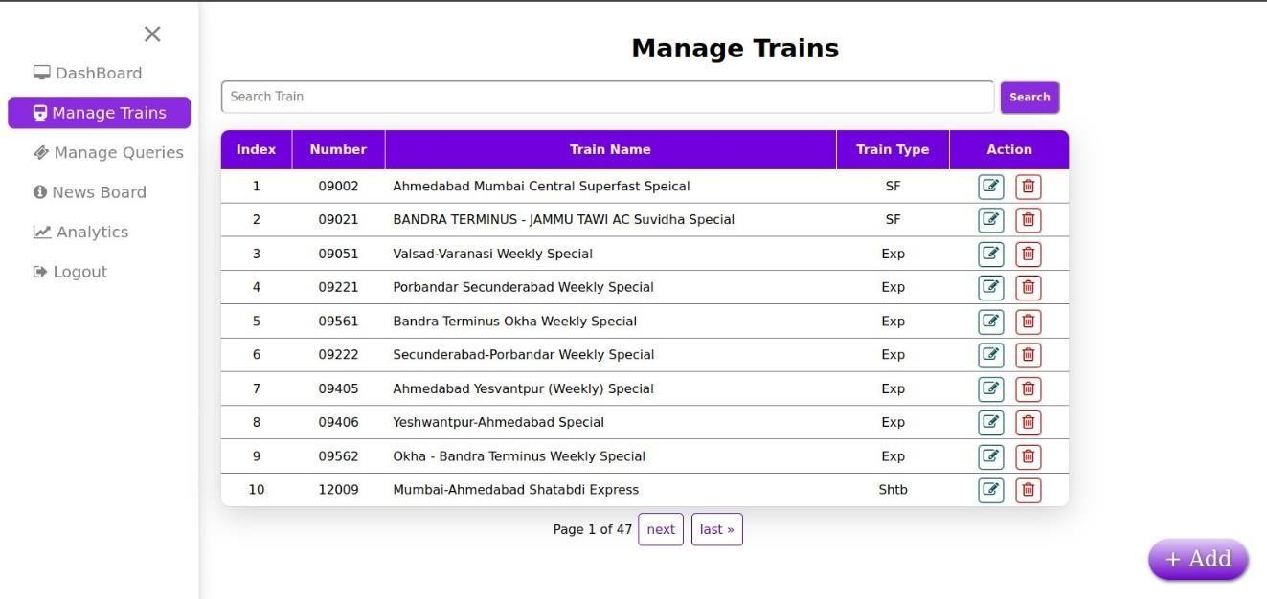

## EDIT TRAIN DETAILS

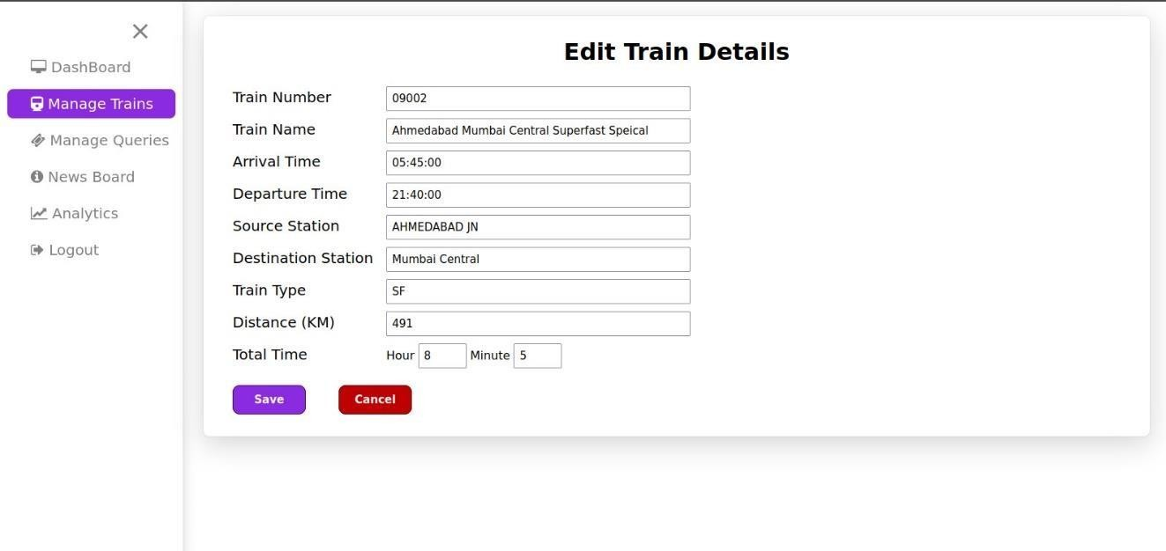

**MANAGE QUERIES**

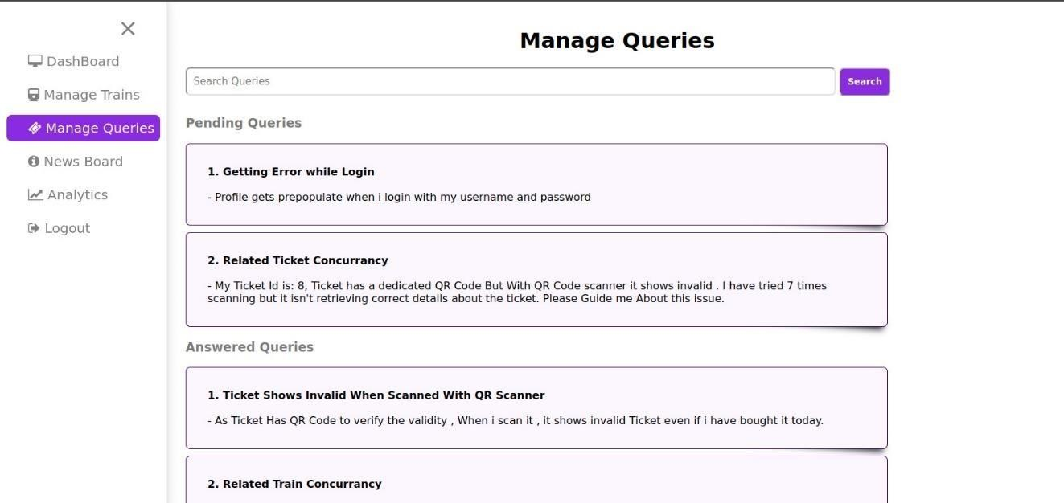

## ANSWER QUERIES

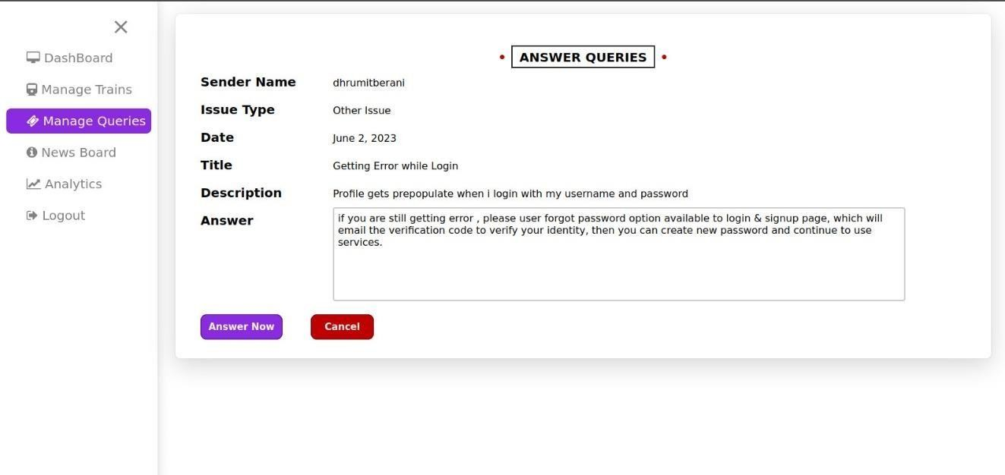

**MANAGE NEWS BOARD**

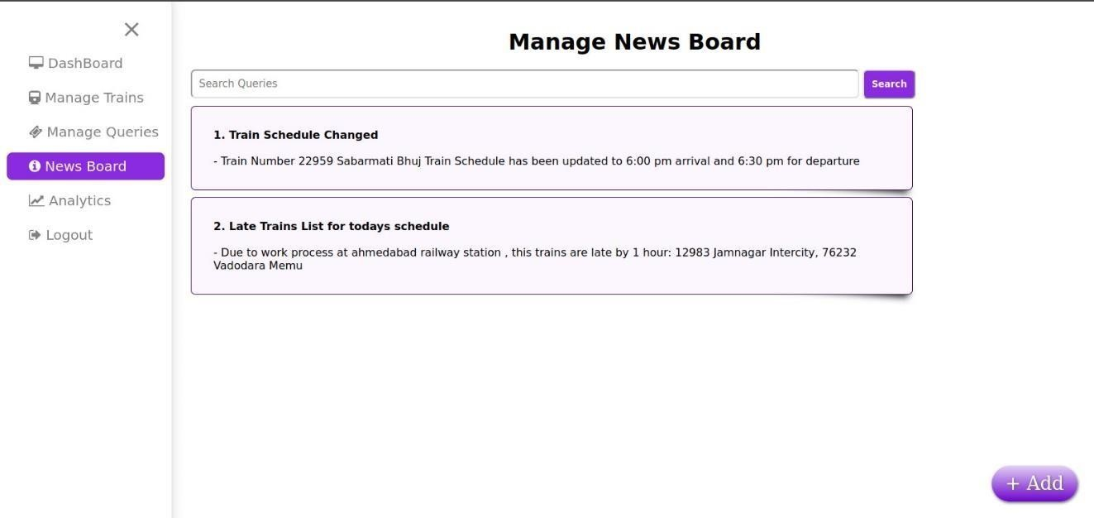

## ADD NEWS

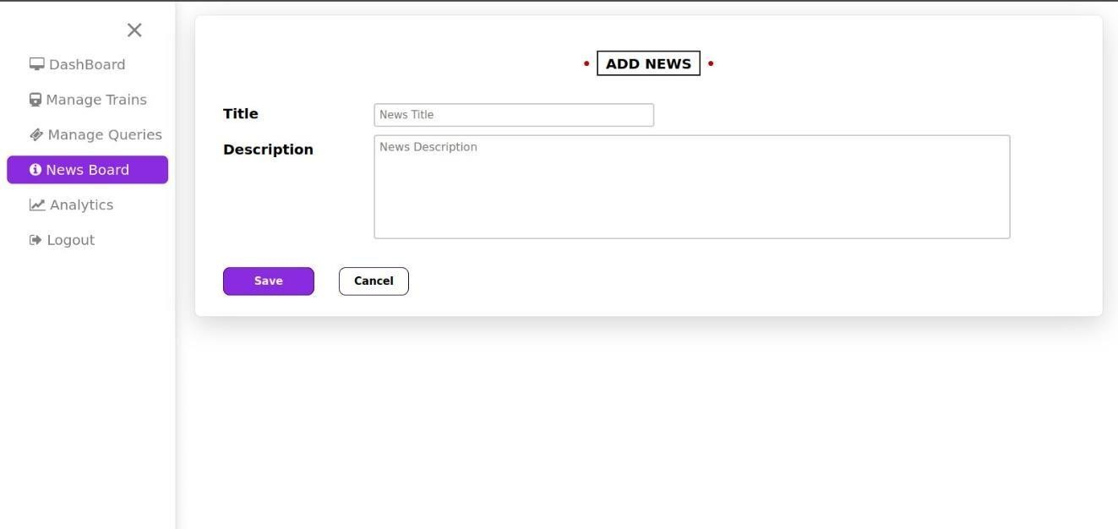

**ANALYTICS SECTION**

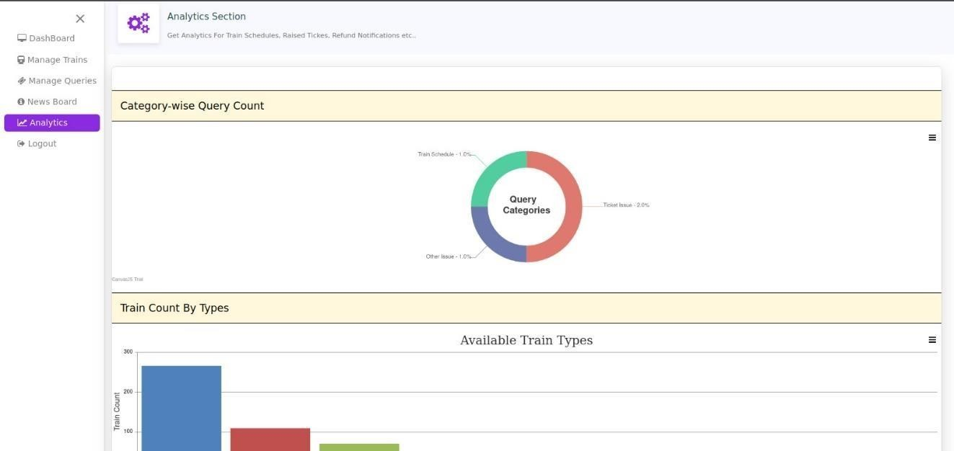

# CONCLUSION

* + The following achievements were made during the project:
  + We had the opportunity to learn a new technology Python
  + Learned to work in PyCharm.
  + We learned to handle a project efficiently and correctly.
  + Learned to tackle various adverse situations while managing and developing software.
  + Learning about the functioning of the IT industry and work ethics in the corporate world.
  + Learning to work with Django and SQLite.
  + Learning about the different phases of software development and the software engineering processes involved in the development of software.

## Main Difficulties encountered

* + The main difficulty that was encountered during this project was that we had to learn a new technology Python as well as a new framework Django with which we were not at all familiar with earlier .
  + Time constraint.
  + Learning the use of SQLite.

# PROPOSED ENHANCEMENT

* + We are trying to build more user friendly website
  + We are trying to make more features available in this project

1. Seat map
2. Birth Map
3. Breakfast
4. Lunch
5. Dinner
   * We are trying to add the more stations in our database
   * We are trying to make website in the sense that more number of people will be able to understand and use our website
   * We are trying to make the mobile application for this project
   * We are trying to book the tickets for the bus or flight.
   * User will be able to search the hotels in user destination city.
   * User will be able to search the tourism place in their destination city

# 7.BIBLIOGRAPHY

* Samuel Dauzon and Arun Ravindran(2017)”Django:Web development with python”
* [**https://www.w3schools.com/python/**](https://www.w3schools.com/python/)
* [**https://www.w3schools.com/js/**](https://www.w3schools.com/js/)
* Monu Singh and Srinivas Arukonda(2021)”Zero to Mastery In Python Programming
* [**https://www.javatpoint.com/django-tutorial**](https://www.javatpoint.com/django-tutorial)

**THANK YOU**